This is a sample paper
A.B. Author, C. Auteur & D.E. Author
Department, University, City, State, Country
ABSTRACT: This text was produced using Microsoft Word according to these instructions, and these guidelines themselves form a sample manuscript. Please adhere as closely to these guidelines as possible. You may use either DOS-based PC or Macintosh. The body text in this paper is only for demonstration purpose.
Sample
Lay out
Sample
Lay out

Introduction
This chapter explains hydraulic and hydrogeologic parameters needed to characterise groundwater flow in a karst aquifer, as well as the methods for their determination. The parameters include: 1) porosity, effective porosity and storage capacity, 2) hydraulic head, 3) transmissivity and hydraulic conductivity, 4) groundwater velocity, and 5) groundwater flow rate. Field test methods include hydraulic borehole tests such as packer and slug tests, and aquifer pumping tests. In a true karst aquifer however, where all characteristic porosity types are developed, an accurate or just an approximate determination of all key groundwater flow parameters is the most difficult task. In addition, virtually all hydraulic test methods commonly applied in karst aquifers have been initially developed for intergranular and fractured porous media, so that the interpretation of their results in karst aquifers, where conduit and channel flows often play the most important role, is not straight-forward and requires considerable practical knowledge.

first heading
HEADING Level 1
In general, rock permeability and groundwater velocity depend on the shape, amount, distribution and interconnectivity of voids. Voids, on the other hand, depend on the depositional mechanisms of carbonate sedimentary rocks, and on various other geologic processes that affect all rocks during and after their formation (see Chapter 2). Primary porosity is the porosity formed during the formation of rock itself, such as voids between the mineral grains, or between bedding planes. It is also often called matrix porosity. Secondary porosity is created after the rock formation, mainly due to tectonic forces (faulting and folding) which create micro and macro fissures, fractures, faults and fault zones in the brittle rock such as limestone. Sedimentary carbonate rocks may become cavernous (karstic) as a result of the removal of part of its substance through the solvent action of percolating water. Although solution channels and fractures may be large and of great practical importance, they are rarely abundant enough to give an otherwise dense rock a high porosity.

Second heading
Heading Level 2
Both the primary (matrix) and secondary porosity can be successively altered multiple times, thus completely changing the original nature of the overall rock porosity. In general, these changes may result in porosity decrease, increase, or altering of the degree of void interconnectivity without a significant change in the overall void volume. However, in true karst aquifers, continuing dissolution of rocks is expected to result in an overall increase in effective porosity. In general, rocks that have both the matrix and the fracture/conduit porosity are referred to as dual-porosity media.

Third heading
Heading Level 3
Confined karst aquifers which do not have major concentrated discharge points in forms of large springs, generally have much lower groundwater flow velocities. This is regardless of the predominant porosity type because the whole system is under pressure and the actual displacement of “old” aquifer water with the newly recharged one is rather slow. Groundwater flow velocity estimates using carbon fourteen isotope dating for the confined portion of the Floridan aquifer in central Florida (Hanshaw and Back, 1974) showed that the average groundwater velocity based on 40 values is 6.9 m/y or 0.019 m/d.

Fourth heading
Heading Level 4
Various approximate calculations of flow velocity have been made based on the geometry of hydraulic features, such as scallops and flutes visible on walls, floors and ceilings of accessible cave passages (e.g., see White, 1988, p. 97–98, and Bögli, 1980, p. 163–164). For example, the calculated flow velocity for a canyon passage in White Lady Cave, Little Neath Valley, Unite Kingdom is 1.21 m/sec and the flow rate is 9.14 m3/sec, for the cross sectional area of flow of 7.6 m2 and scallop length of 4.1 cm (White, 1988).

figures and tables

Figures
This distinction is important in terms of groundwater flow, which has very different characteristics in fractures and conduits compared to the bulk of the rock. Figure 1 is a comparison beween total porosity of main sedimentary rock types. As can be seen, limestone has the widest porosity range of any consolidated sedimentary rock.
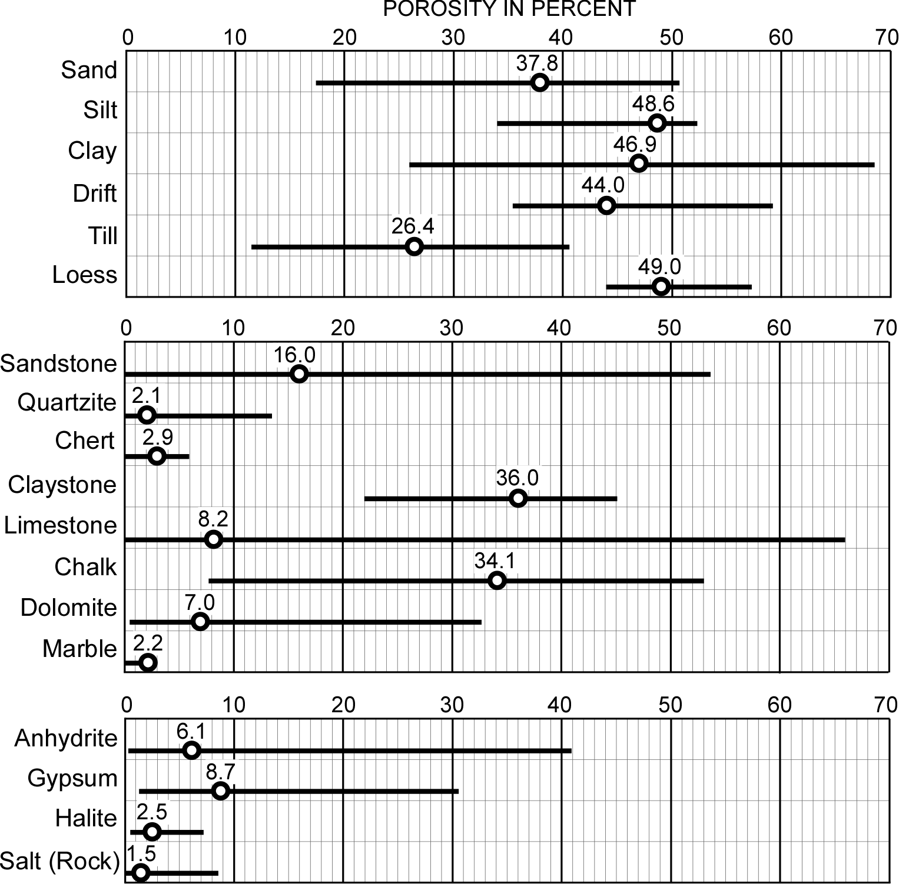
Figure 1: Porosity range (horizontal bars) and average porosities (circles) of unconsolidated and consolidated sedimentary rocks (Kresic, 2006; porosity values processed from Wolff, 1982).
Figure Caption

Tables
The same general area with carbonate rocks may be subject to multiple periods of karstification depending on the depositional and tectonic history. In such cases it is possible to find very transmissive zones, together with karst conduits, at greater and varying aquifer depths and/or below overlying non-carbonates. These zones often mark position of a paleo water table where karstification intensity was the highest (Table 1).

Table. 1: This is an example of a table
Table Caption
Table
M | X | Y | E_{1/2} Reduction | E_{1/2} Oxidation
Mo | Cl | OPh | -0.42 | —
W  Align entries left | Cl | OPh | -0.86  Align numbers on decimal point | —
Mo | OPh | OPh | -0.74 | —
W | OPh | OPh | -1.20 | —
Mo | Cl | py | -1.60 | +0.44
 | Cl | py-NMe₂-4 | -2.25 | 0.00
Note: This will be used to explain abbreviations in the table
Table Note

listing

Bullet listing
Fracture aperture and thickness are two parameters used most often in various single-fracture flow equations, while spacing between the fractures and fracture orientation is used when calculating flow through a set of fractures. However, these actual physical characteristics are not easily and meaningfully translated into equations attempting to describe flow at a realistic field scale:
- Fracture aperture is not constant and there are voids and very narrow or contact areas called asperities. Various experimental studies have shown that the actual flow in a fracture is channeled through narrow, conduit-like tortuous paths and cannot be simply represented by the flow between two parallel plates separated by the “mean” aperture (Cacas, 1989).
Single citation
- Because of stress release, the aperture measure at outcrops or in accessible cave passages is not the same as an in-situ aperture. Aperture measured on drill cores and in borings is also not a true one - the drilling process commonly causes bedrock adjacent to fractures to break out thereby increasing the apparent widths of fracture openings as viewed on borehole-wall images (Williams & Casas, 2001).
Double citation
- Fractures have limited length and width, which can also vary between individual fractures in the same fracture set. Spacing between individual fractures in the same set can also vary. Since all these variations take place in the three-dimensional space, they cannot be directly observed, except through continuous coring or logging of multiple closely spaced boreholes, which is the main cost-limiting factor (Williams et al., 2001).
Multiple citation

Numbered listing
There are additional complicating factors when attempting to calculate flow through natural karst conduits using the pipe approach:
- Flow through the same conduit may be both under the pressure and with the free surface.
- Since pipe/conduit walls are more or less irregular (“rough”), the related coefficient of roughness has to be estimated and inserted into the general flow equation.
- Conduit cross section may vary significantly over short distances.
- The flow may be both laminar and turbulent in the same conduit, depending on the flow velocity, cross-sectional area and wall roughness. The irregularities that cause turbulent flow are mathematically described through the Reynolds number and the friction factor.

equations
A schematic of a formation having a network of dissolutional openings intersecting a network of “diffuse” fractures (in which the groundwater flow is slow), and being pumped by a fully-penetrating well. The equations and boundary conditions governing the pumping of water from a well in a dual-porosity karst formation are given by Greene et al. (1999) and described below in Equation 1.
Equation Number
Flow in dissolutional openings:
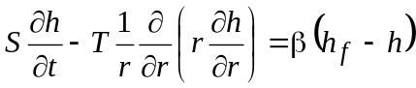 (1)
Equation
Inline
equation
Initial condition in dissolutional openings: 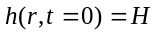.
Boundary conditions in dissolutional openings:
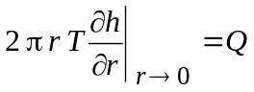 (2)
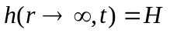 (3)
Flow in fractures: 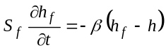
Initial condition in fractures: 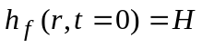

summary
Equivalent porous media generalisations in karst hydrogeology may be unavoidable in many cases, but should always be based on a solid overall knowledge of the specific aquifer system in question. Calculations of groundwater flow rates through various portions of a karst aquifer should be based on the hydraulic heads observed in monitoring wells only when there is a clear understanding of the underlying hydrogeology. Borehole packer tests are used to evaluate discrete intervals in the immediate borehole vicinity and should not be used alone to calculate representative flow rates in the aquifer. Combining borehole flowmeter tests and aquifer pumping tests is arguably the only method that can be used to determine aquifer transmissivity and hydraulic conductivity reasonably accurately. Caution should be exercised when interpreting results of aquifer pumping tests: whenever possible, one should account for the actual representative thickness of the aquifer being pumped (i.e., for the preferential zones providing most of the well flow) rather then for the entire well length open to the aquifer.
References
Arrami, M. & Garner, H. (2008) A tale of two citations. Nature. [Online] 451 (7177), 397–399. Available from: http://www.nature.com/nature/journal/v451/n7177/full/451397a.html [Accessed 20th January 2008].
Journal article: online/electronic

Map

British Geological Survey (1998) South London, 270. 1: 50 000. London.
British Standards Institution (2003) BS 5950-8:2003. Structural use of steelwork in building: code of practice for fire resistant design. London, BSI.
Standard

Chibber, P.K. & Majumdar, S.K. (1999) Foreign ownership and profitability: Property rights, control, and the performance of firms in Indian industry. Journal of Law & Economics, 42 (1), 209–238.
Journal article: print

European Space Agency. (2008) ESA: Missions, Earth Observation: ENVISAT. [Online] Available from: http://envisat.esa.int/ [Accessed 3rd July 2008].
Web page/website

Harrison, R. (r.e.harrison@imperial.ac.uk) (10 June 2009) Plagiarism tutorial. E-mail to: Weiss Johnson, W. (m.weiss@imperial.ac.uk).
Personal communication

E-mail

Law, James. Engineering consultant. (Personal communication, 26th April 2004).
d

Leatherwood, S. (2001) Whales, dolphins, and porpoises of the western North Atlantic. U.S. Dept. of Commerce. Report number: 63.
Report

Moran, M. J. (2005) Engineering thermodynamics. In: Kreith, F. & Goswami, D. Y. (eds.) The CRC handbook of mechanical engineering. 2nd edition. Boca Raton, FL, CRC Press. pp. 2–81.
Book: chapter in an edited book

Read, B. (2008) Anti-cheating crusader vexes some professors. Chronicle of Higher Education. [Online] 54 (25). Available from: http://global.factiva.com/ [Accessed 18th June 2009].
Journal article: online/electronic

Simons, N.E., Menzies, B. & Matthews, M. (2001) A Short Course in Soil and Rock Slope Engineering. London, Thomas Telford Publishing.
Book: online/electronic

Simons, N.E., Menzies, B. & Matthews, M. (2002) A Short Course in Soil and Rock Slope Engineering. [Online] London, Thomas Telford Publishing. Available from: http://www.myilibrary.com?ID=93941 [Accessed 18th June 2008].
Book: print
Wagner, G. (2006) Structural and functional studies of protein interactions in gene expression. [Lecture] Imperial College London, 12th December.
Lecture / Presentation

Wang, F., Maidment, G., Missenden, J. & Tozer, R. (2007) The novel use of phase change materials in refrigeration plant. Part 1: Experimental investigation. Applied Thermal Engineering. [Online] 27 (17–18), 2893–2901. Available from: doi:10.1016/j.applthermaleng.2005.06.011 [Accessed 15th July 2008].
Journal article: online/electronic

Wittke, M. (2006) Design, construction, supervision and long-term behaviour of tunnels in swelling rock. In: Van Cotthem, A., Charlier, R., Thimus, J.-F. and Tshibangu, J.-P. (eds.) Eurock 2006: Multiphysics coupling and long term behaviour in rock mechanics: Proceedings of the International Symposium of the International Society for Rock Mechanics, EUROCK 2006, 9-12 May 2006, Liège, Belgium. London, Taylor & Francis. pp. 211–216.
Conference Proceedings: individual paper

